Activity 4
Waterworks or production of drinking water
We have planned an excursion to a water treatment plant in the waterworks.
Task 1:
Each of you will prepare questions that you would like to ask throughout the excursion. These questions should relate to water pumping, mechanical and chemical purification of water, history and problems of supply, etc., in short, everything that you are interested in as for water treatment.
Your questions:
…………………………………………………………………………………….............................
……………………………………………………………………………………………………………………………………………………………………………………………………………………………………………………………………………………………….........................................?

*Waterworks equipment photos for example can be found at: http://ostravablog.cz/
Task 2:
From the excursion you have learned how water is treated in waterworks. Add the individual phases of water circulation into the following picture of water industry.
Phases:
A – monitoring of water quality in the watercourse
B – water meter
C – cleaned water back to the nature
D – supply
E – waste water
F – pumping of water
G – purification of waste water
H – waste water in the household
I – storage of drinking water
J – production of drinking water
K–drinking water in the household
L – inspection and chlorination
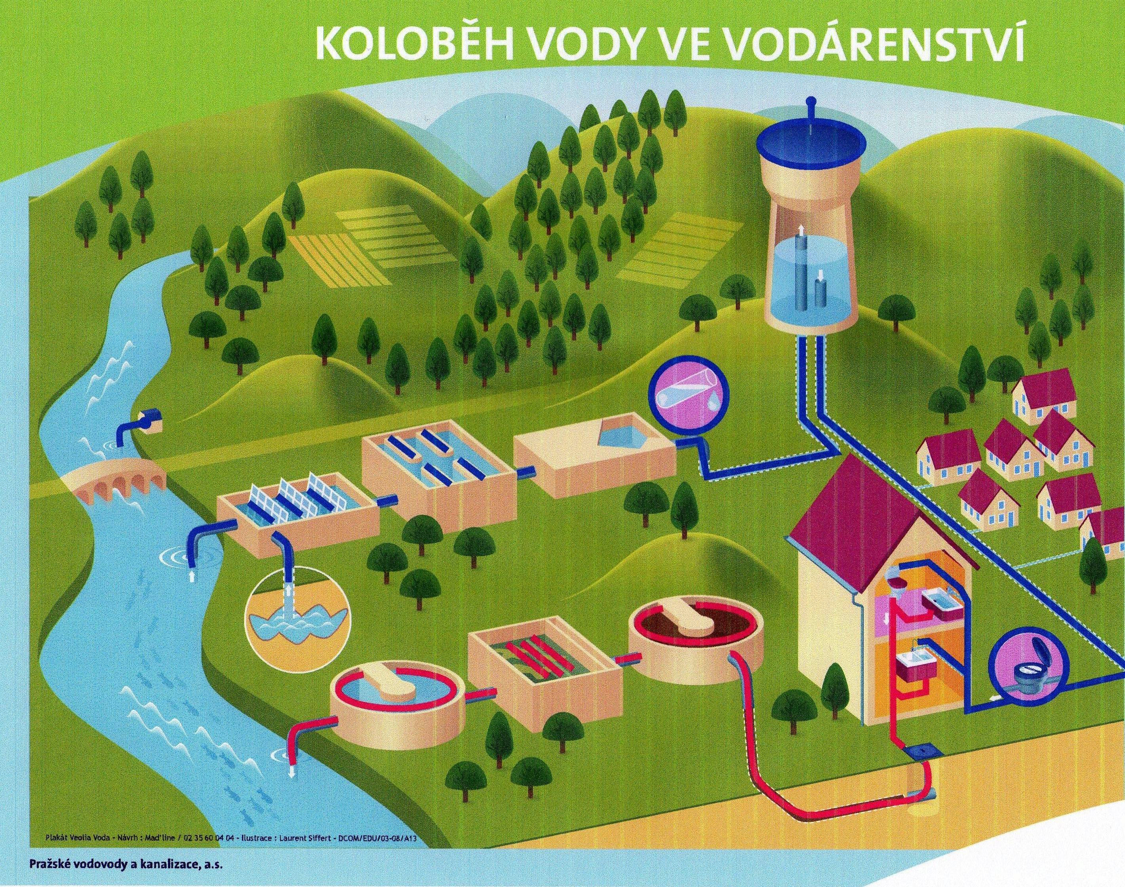
Source: http://www.pvk.cz/

