Activity 5
Can we get drinking water?
Imagine that you are in South Asia. You are very thirsty and the only water available is muddy water from puddles. How to purify this water to make it drinkable? You only have these things: PET bottle, sand, hay, crumpled paper, a glass of dirty water, skewers, knife, and matches. Propose a procedure that could be used for water purification. Which tools would you use?
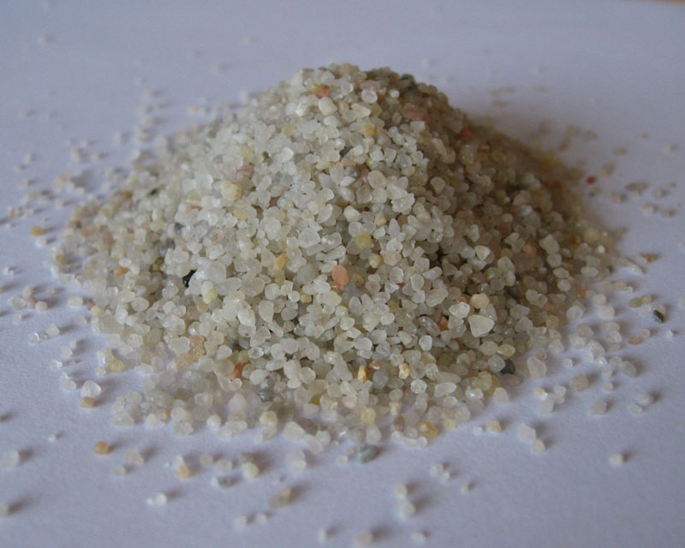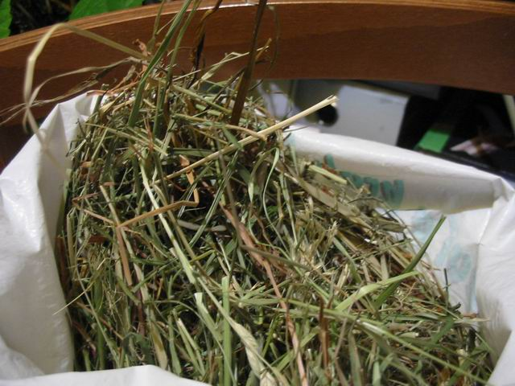
Source: http://www.flexiobklady.cz/produkty-pisek-prirodni.php Source: http://kralicek.wbs.cz/Krmeni.html

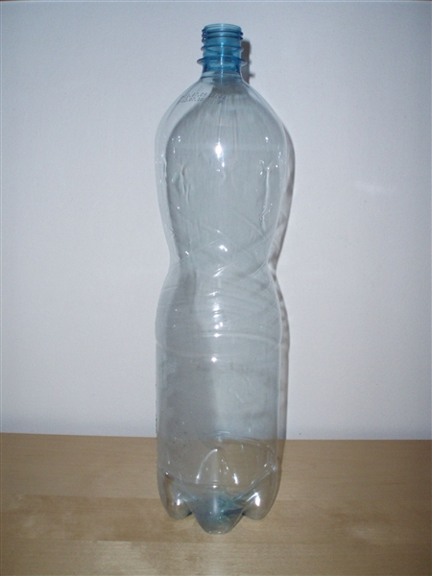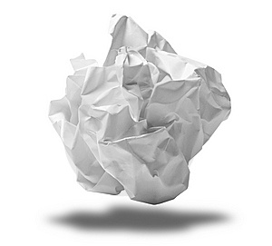
Source: http://horz.cz/spotreba.asp Source: http://www.stockphotos.cz/image.php?img_id=14477875&img_type=1

Hypothesis: …………………………………………………………………………………….......
Justification: ………………………………………………………………………………….........

Tools: …… ……………………………………………………………………………....................
Justification: ………………………………………………………………………………………..
Working procedure: ……………………………………………………………………………….
………………………………………………………………………………………………………………………………………………………………………………………………………………………………………………………………………………………………………………………………

Result:
Has the water been purified? ………………………………………………………………………

Conclusion (What was incorrect?, What should have been correct?, Why does it work like this?):
………………………………………………………………………………………………...………………………………………………………………………………………..……...........................

