Activity 6
Analysis of beverages
In this task, you are provided with different types of packaging of selected beverages that you can bring yourselves. They may be similar to those in the pictures:
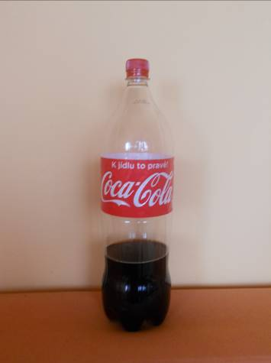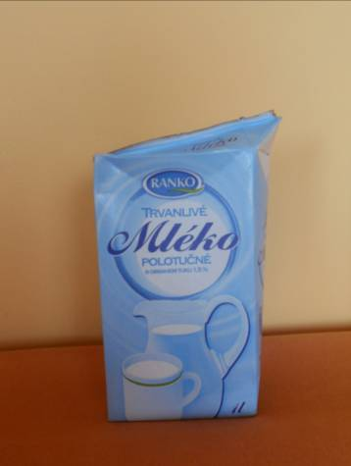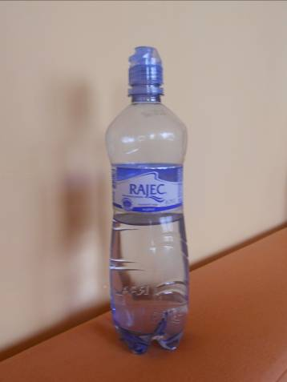
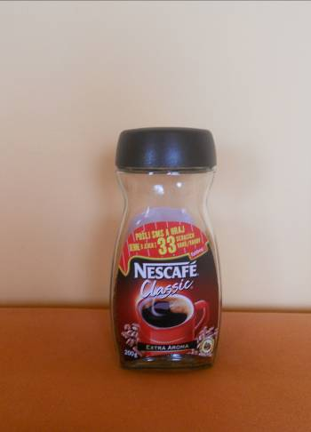 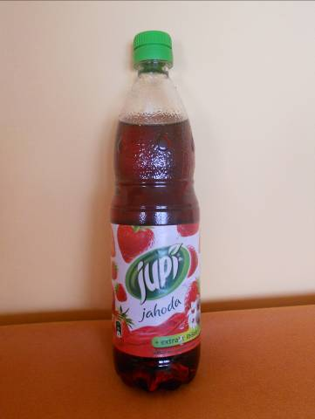 Photo: Martina Nedomová
Task 1:
First, ask yourselves questions that would apply to the analysis of the composition of the given beverages. These questions may relate to their different composition. For inspiration you can use the following questions in the worksheet. According to your own opinion, answer your questions. Thus the hypotheses will be established that you will verify in the following task.
- Question:
Hypothesis:………………………………………………………………………………..........
- Question:
Hypothesis:………………………………………………………………………………..........
- Question:
Hypothesis:………………………………………………………………………………..........
- Question:
Hypothesis:………………………………………………………………………………..........
- Question:
Hypothesis:………………………………………………………………………………..........
- Question:
Hypothesis:………………………………………………………………………………..........
- Question:
Hypothesis:………………………………………………………………………………..........
- Question:
Hypothesis:………………………………………………………………………………...............

Task 2:
How would you proceed to verify your hypotheses? Apply your proposal of procedure for how to get answers to questions. For inspiration you can use the table in the worksheet.
Procedure proposal:……………………………………………………………………………....
………………………………………………………………………………………………………....

beverage | energy value (kJ) | proteins (g) | saccharides/out of them sugars (g) | fats (g) | fibre(g) | sodium (g) | caffeine (g)

Task 3:
Go back to the questions and compare your answers with the results of your investigation and form a conclusion. If the answers were icorrect, write about why you first probably thought like this. You can write about what was a surprise for you and what attracted your attention.
Conclusion:………………………………………………………………………………………………………………………………………………………………………………………..................

Task 4:
During the analysis you met the energy value of beverages.
- What type of energy is it and why do we need it?
Hypothesis:………………………………………………………………………………..........
…………………………………………………………………………………………................
Procedure to verify the correctness of hypothesis: …................................................
…………………………………………………………………………………………................
Conclusion:……………………………………………………………………………………..............................................................................................................................................
- How much energy do you need?
Hypothesis:………………………………………………………………………………..........
…………………………………………………………………………………………................
Procedure to verify the correctness of hypothesis: ……............................................
…………………………………………………………………………………………................
Conclusion:……………………………………………………………………………………........................................................................................................................................................

