Activity 7
How does the water go trough our body after drinking?
Below you will find the pictures that show the individual parts of the human body. Your task is to establish a hypothesis refer briefly to the processes the water undergoes in the given picture and draw them into the path of water as a line.
Start from your current knowledge. Then suggest how you would verify whether your answers are correct. Once verified, go back to the pictures and write down the correct results.

Picture A: Oral cavity

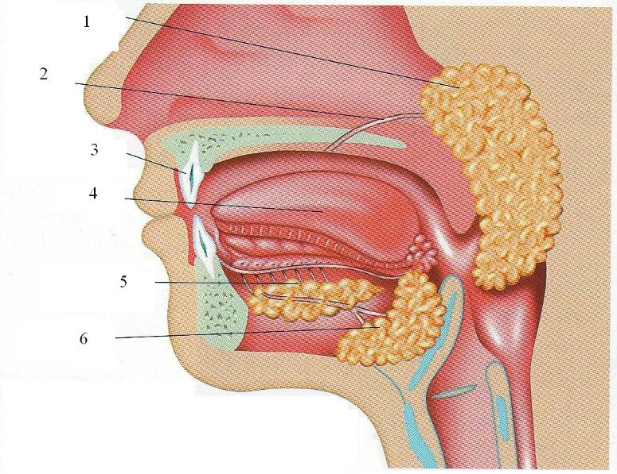 Source: Winston, 2005
1 – parotid salivary gland
2 - salivary duct
3 - tooth
4 - tongue
5 - sublingual salivary gland
6 - submandibular salivary gland

What happens to water in this part of the organism? Hypothesis:……………………………………………………………………………………........
Result:…………………………………………………………………………………….................

Picture B: Stomach with part of the duodenum
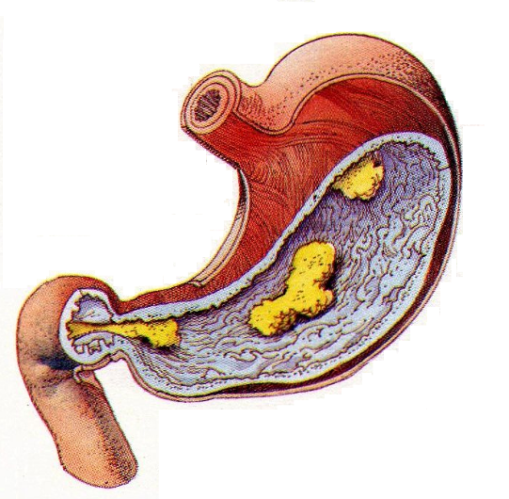 Source: Adams, 1992

What happens to water in this part of the organism? Hypothesis:……………………………………………………………………………………........
Result:…………………………………………………………………………………….................

Picture C: Small intestine and colon

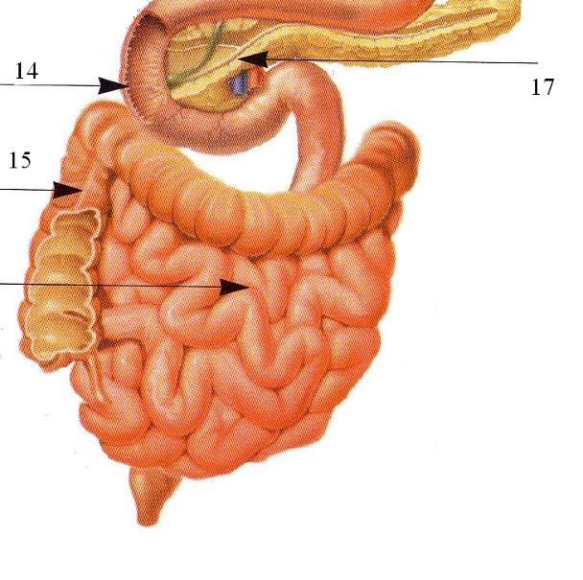 Source: Trojan, Schreiber, 2002
14 - duodenum
15 - colon
16 - small intestine
17 - pancreas

16

What happens to water in this part of the organism? Hypothesis:……………………………………………………………………………………........
Result:…………………………………………………………………………………….................
Picture D: Small intestina wall
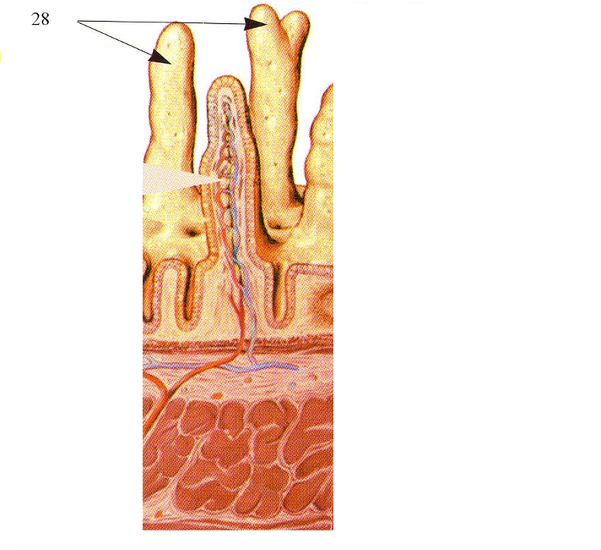 Source: Trojan, Schreiber, 2002
28 – willi

What happens to water in this part of the organism? Hypothesis:……………………………………………………………………………………........
Result:…………………………………………………………………………………….................

Picture E: Kidney
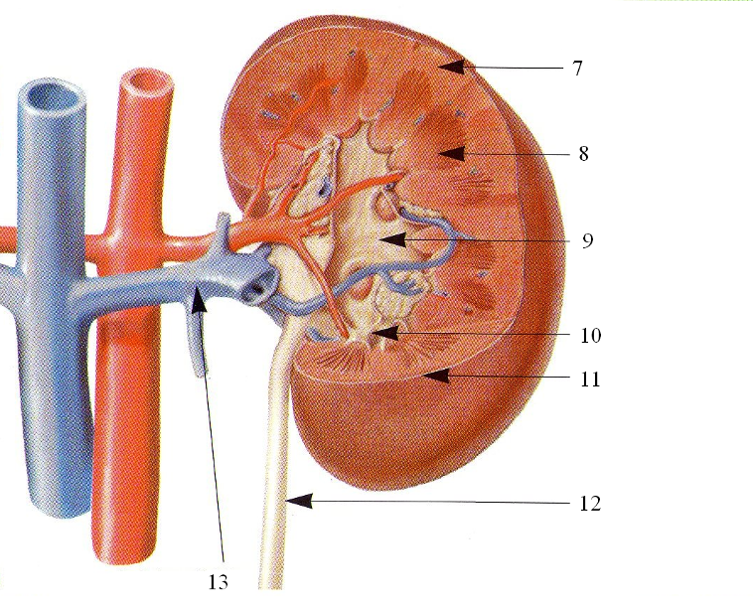 Source: Trojan, Schreiber, 2002
7 - kidney cortex
8 - kidney medulla
9 - renal pelvis
10 - cup of kidney
11 - fibrous casing
12 - ureter
13 - renal vein

What happens to water in this part of the organism? Hypothesis:……………………………………………………………………………………........
Result:…………………………………………………………………………………….................
Picture F: Nephron

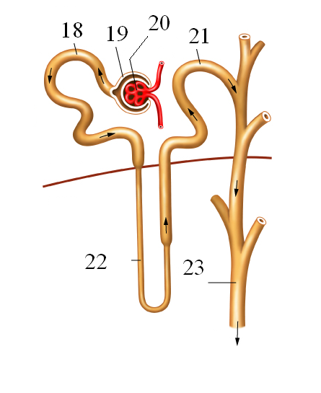 Source: www.beltina.org
18 - proximal tube
19 - Bowman pouch
20 - glomerulus
21 - distal tube
22 - loop of Henle
23 - collecting duct

What happens to water in this part of the organism? Hypothesis:……………………………………………………………………………………........
Result:…………………………………………………………………………………….................

Picture G: Urine bladder

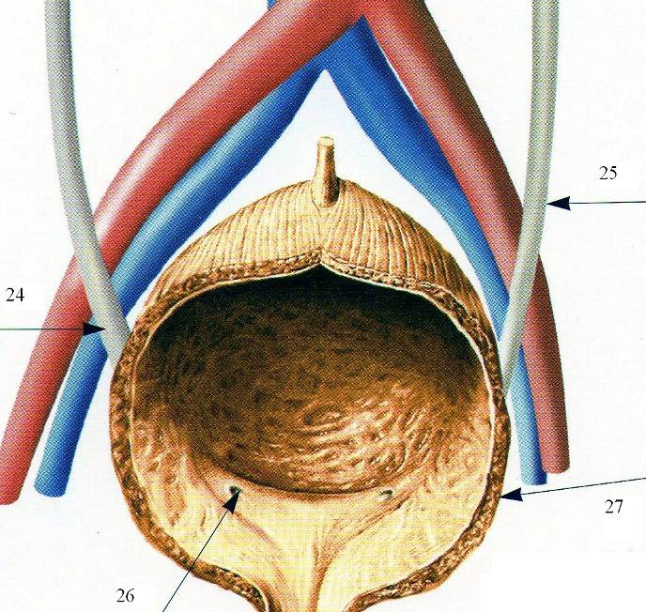 Source: Trojan, Schreiber, 2002
24 - ureter
25 - ureter
26 - outcome of the ureter
27 – urine bladder

What happens to water in this part of the organism? Hypothesis:……………………………………………………………………………………........
Result:…………………………………………………………………………………….................

Procedure to verify all hypotheses:…………………….......................................................
………………………………………………………………………………..….…………...............
…………………………………………………………………………………...…………...............
…………………………………………………………………………………...…………...............
Conclusion: (evaluate your results)
……………………………………………………………………………………………..................
……………………………………………………………………………………………..................
……………………………………………………………………………………………..................

The working text that can be used to verify your hypotheses:
Water is a major constituent of the whole organism. The amount of water in the body is dependent on the age, weight and gender of the individual. The total amount of water in the body of an adult is approximately 30 to 40 liters, i.e. about 50 to 60%. Water is taken into the body through the mouth as it is with food. Water passes through the pharynx and esophagus into the stomach, then it moves into the small intestine and colon. The amount of water that is excreted along with feces is about 100 ml. We daily drink 1.5 to 2.5 liters of water. So, where to does water disappear from the organs of the digestive system? Absorption occurs mainly in the colon, and only in smaller quantities in the small intestine. Along with water, nutrients such as fats, sugars, proteins and ions are also absorbed. But what the absorption actually is? The inner wall of the intestine is formed by the so-called villi, which are very well supplied with blood. Each villus is connected with intestinal capillaries into which the water enters through the intestinal wall and is further distributed with nutrients throughout the whole body. However, in a similar manner, the blood also receives waste and unwanted substances; therefore the body must get rid of these substances. To remove these substances from the blood is the task of kidneys. The blood is brought into the kidney by a renal artery, which is divided in the kidney into small capillaries. These then participate in the construction of the nephron (anatomical and functional unit of kidneys). Blood vessels in the kidney cortex form a vascular blob, the so-called glomerulus, where from fluid, the so-called primary urine, is filtered into Bowman's pouch. Daily, about 170 liters of this urine is created. This filtrate then proceeds to the kidney marrow via other parts of nephron, i.e. via a proximal tubule (duct of 1st order), loop of Henle and distal tubule (duct of 2nd order). In these parts, there occurs an intense absorption of water and nutrients into the blood capillaries that converge in the renal vein. The resulting fluid is called the final urine. This urine is then drained by a collecting duct, where the water is also resorbed into the renal calyces. Renal calyces converge in the renal pelvis, followed by the urethra, which carries urine to the bladder. Here, urine accumulates and when the bladder is filled up to about 350 to 400 ml, it results in the need to urinate. This feeling can be suppressed up to the volume of 700 ml. From the bladder, urine flows out through the urethra (adapted from Novotny, Hruška, 2007, Jelinek, Zicháček, 2002).

