1. Can we use sound to “see”?

- Bats are able to navigate and to hunt for insects in the dark, how do you think bats can “see” in the dark?

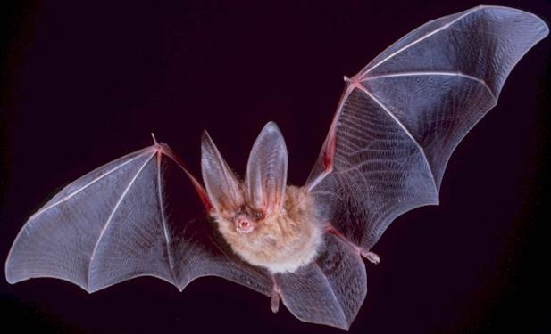

- Do you know what is ‘echolocation’? Discuss with your classmate.
Describe what you think this means.

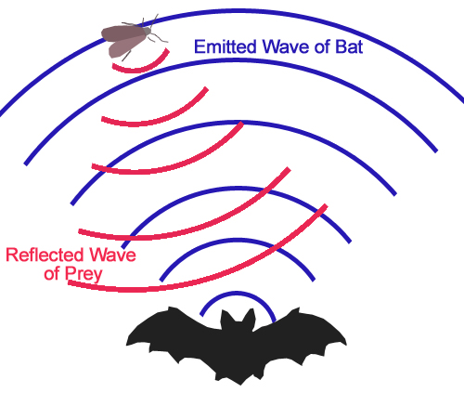
- Most bats communicate and navigate with high-frequency sounds – ultrasonic sounds. By emitting series of ultrasonic sounds and detecting the echoes that return from solid objects within range,
they are able to locate those objects.
This allows them to not only avoid stationary objects such as trees and buildings, but also to identify and target night-flying insects. This technique, called 'echolocation' is so accurate that bats can detect objects as fine as a human hair.

- Can blind people use echolocation to "see" the same way as bats do?
What is your hypothesis?

- Watch the discovery channel movie ‘Real-life Bat Man’. (http://dsc.discovery.com/videos/is-it-possible-real-life-bat-man.html)

- Was your hypothesis correct?

- Close your eyes and try to locate objects near you in the similar way as shown in the movie. How difficult is it?

- You have learned that you can get position data from sound. It is as simple as listening for sound echoes.
Imagine you are standing in front of high building or high wall. You clap your hands once and listen for the echo. With a stopwatch you can time the interval between clap and echo.
- How can you use this information to find the distance to the building?
Do you need any other data? If so, what?

- Now you are going to use the echo method to find a unknown length of a tube.
In this experiment you will need a computer, sound sensor (connected to a data-logger) and a cartoon hollow tube (could also be a long vacuum cleaner pipe). Close one end of the tube. This can be done by inserting a plug or placing a book against the end of the tube.

- Connect the sound sensor to your data-logger.
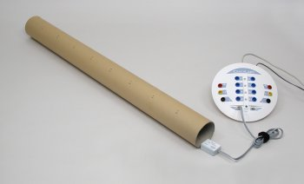
- Start the Coach 6 activity “Echo”.
- Place the sound sensor at the opening of the tube. Position it so that it can detect the initial sound and the echo coming back down the tube.
- Snap your fingers near the opening of the tube and record the sound signal. The sound should be loud and sharp.
- In Coach activity the recording is triggered, after clicking the Start button the computer will wait until you make an initial sound, then the measurement is automatically started.

- Identify the first echo reflected from the closed side of the tube. Determine the time between initial sound and its echo.

- What is the speed of sound in this tube?

- What is the distance travelled by this sound pulse in this time?

- If Δt is the time between sound emission and detection of the echo, and v is the speed of sound, then the length of the tube:

- Are there any other echoes recorded? If so identify those by determining the time between sound production and the found echoes.

- Do you think that sound can be used to measure distances?

