Activity 2.2A: Station 1: Coloured Chemical Substances in Water

Worksheet 1:

Discuss in your group and then perform the following activities

Experiment 1-Indicative Procedure

- i. Pour 120 mL of distilled water into a 150mL beaker. If you placed one drop of red food colouring at the centre of the bottom of the beaker, what changes do you predict will occur; try to briefly explain your predictions.
_________________________________________________________________

ii. Pour distilled water into a Petri dish (up to approximately 1 cm height). If you placed a few crystals of potassium permanganate in the centre of the Petri dish, what changes do you predict will occur; try to briefly explain your predictions.
_________________________________________________________________

Imagine that you wear magic magnifying glasses, so that you can clearly see the content of the Petri dish, what kind of changes do you expect to observe in the Petri dish; Draw your expectations and observations after 1 min, after two minutes and after 10 minutes, in the following diagrams:

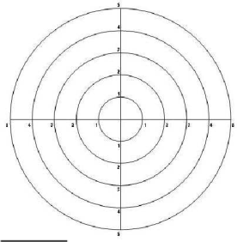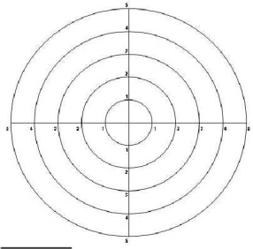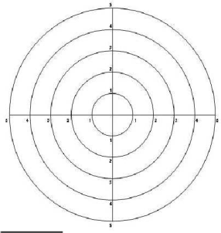
After 1 min after 2 mins after 10 minutes

- Conduct the following experiments:
i. Using a plastic dropper, put 3-4 drops of red food colouring in the center of the bottom of a beaker (A) containing 120 mL of distilled water.
ii. Using a plastic dropper, put 3-4 drops of red food colouring in the center of the surface of a beaker (B) containing 120 mL of distilled water.
iii. Put 2-3 crystals of Potassium permanganate on the center of a Petri dish using forceps.
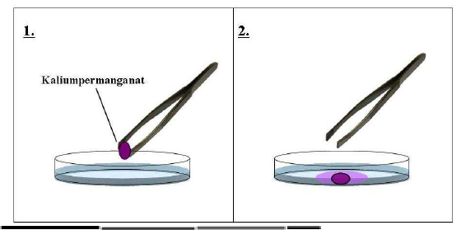
Potassium permanganate

- Make as many careful observations as possible concerning the three experiments and try to record the way the three substances are moving and what changes in colour are progressively happening in the three cases. Draw somehow, the movement of Potassium permanganate and the red food colouring substance in each of the three containers, in three different consecutive drawings indicating your observations after 2, 5 and 10 minutes (question 5).

Discuss in your group and carefully record your observations and your interpretations for the following questions: (questions 4, 5, 6, 7, 8, 9, 10)

Results

- Describe your observations for the Petri dish and the other two containers: _________________________________________________________________
_________________________________________________________________
_________________________________________________________________

- Draw in the following diagrams your observations concerning the movement of Potassium permanganate time period and justify your drawings.

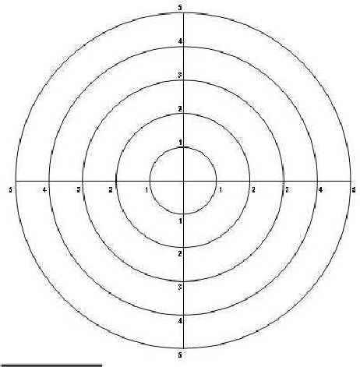

After 2 minutes After 5 minutes After 10 minutes

Explanations

6. a) Explain the movement of Potassium permanganate in the Petri dish.

b) Explain the movement of the red food colouring in the beakers A and B.
______________________________________________________________

7. Were your predictions and your drawings the same as your observations and their consequent explanations;
_________________________________________________________________
_________________________________________________________________
_________________________________________________________________
_________________________________________________________________
- Imagine that you wear magic magnifying glasses. In such a case, draw the contents of the beaker before and after pouring the drops of the red food colouring

1
2 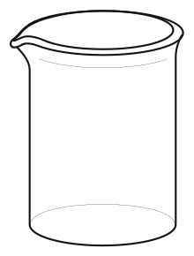

9. What kind of changes occur in the Petri dish and in the two beakers after adding either potassium permanganate and the red food colouring: How do you justify your answers;
_______________________________________________________________
_______________________________________________________________
- Describe briefly your observations in the beaker where the red food colouring was added. In your description, please use the following terminology: particles, movement, water, distributed, homogeneously, diffusion.
_______________________________________________________________
_______________________________________________________________
_______________________________________________________________
_______________________________________________________________

- At the corner of your classroom, the chemistry teacher put an open small bottle containing pure alcohol, but she did not mention anything to her students. John smelled the alcohol after a minute, but Jack smelled it after several minutes.
i. Why do you think the two students smelled the alcohol at different times and why.
ii. What is the relation of the smell of the alcohol with the experiments that you have performed earlier?
_______________________________________________________________
_______________________________________________________________
_______________________________________________________________
_______________________________________________________________

Homework

- How many particles are included in a tiny crystal of potassium permanganate;
A. 100 000 000 000 000 000 000 000 Β. 1 000
C. 100 000 000 D. 100 000

- Describe the phenomenon of diffusion that is presented in the following drawings.
(White spheres represent particles of water and the other spheres represent particles of potassium permanganate.)

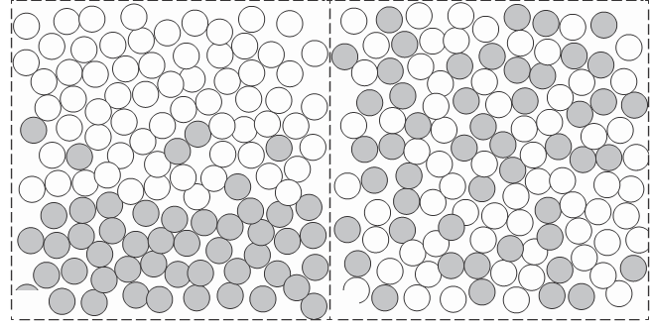
- Do you expect that the particles of a gas behave the same way as the particles of potassium permanganate and the particles of the red food colouring substance; Justify your answer.
_____________________________________________________________
_____________________________________________________________
- Is the following statement true or false; explain why.
“The same experiment can be performed using cooking salt instead of potassium permanganate. The only difference relates to the fact that we will not be able to observe the movement of the particles, because the cooking salt does not have any colour.” __________

